**CODE:**

**from random import \***

**from random import \***

**while True:**

**temperature = randrange(0,100)**

**humidity = randrange(0,100)**

**if (temperature>=50):**

**print(“Alarm”)**

**else:**

**print(“No Alarm”)**

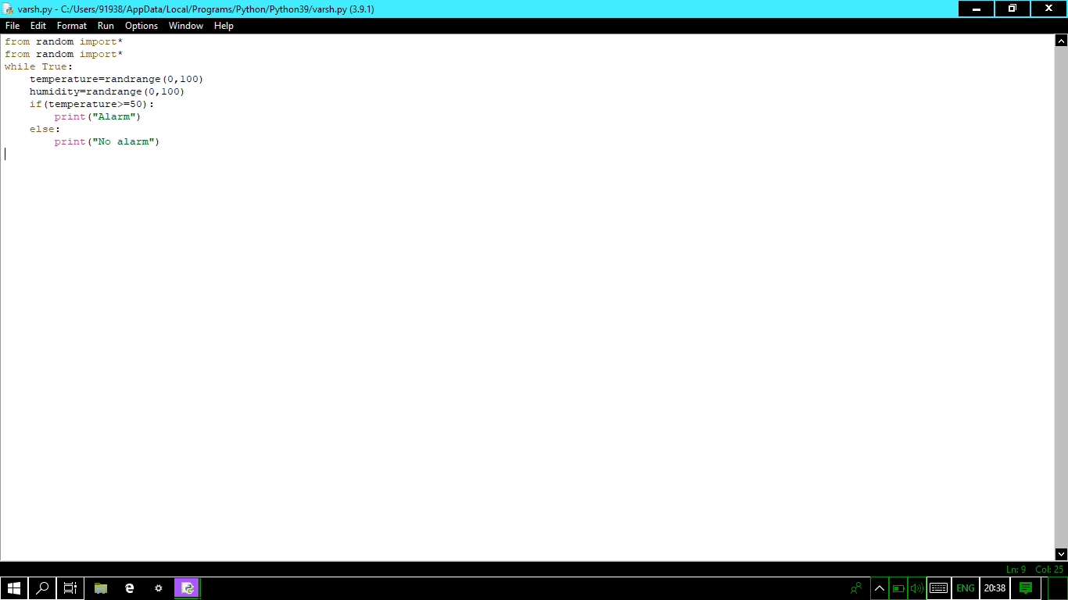

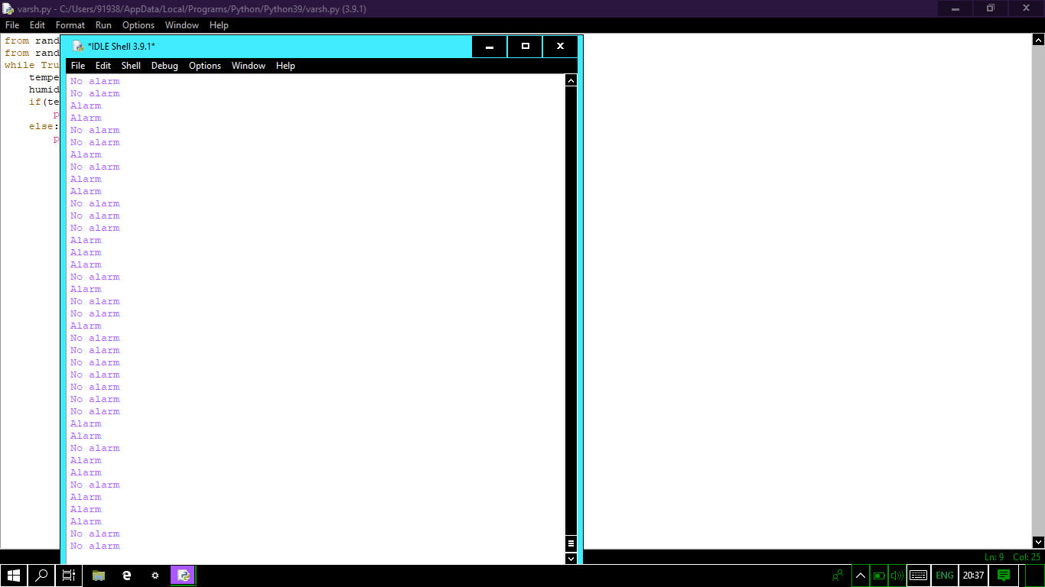

**ASSESMENT NO:2**

**VARSHA.E**

